Usuario HR:

1. Tablas: 7

|  |  |
| --- | --- |
| JOB_HISTORY | TABLE |
| EMPLOYEES | TABLE |
| JOBS | TABLE |
| DEPARTMENTS | TABLE |
| LOCATIONS | TABLE |
| COUNTRIES | TABLE |
| REGIONS | TABLE |

* 1. Tabla **COUNTRIES , contiene 25 registros**

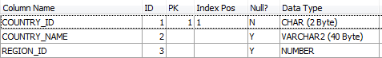

* 1. Tabla, DEPARTMENTS contiene 27 registros

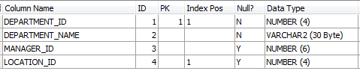

* 1. Tabla, EMPLOYEES contiene 107 registros

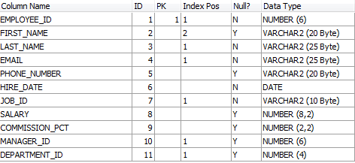

* 1. Tabla, JOBS contiene 19 registros

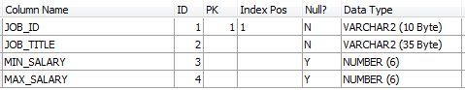

* 1. Tabla**,** **JOB_HISTORY contiene 10 registros**

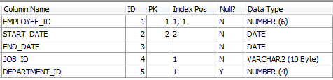

* 1. Tabla**,** **LOCATIONS contiene 23 registros**

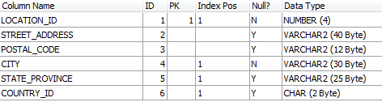

* 1. Tabla**,** **REGIONS contiene 4 registros**



1. Vistas: 1

|  |  |
| --- | --- |
| EMP_DETAILS_VIEW | VIEW |

1. Triggers : 2

|  |  |
| --- | --- |
| UPDATE_JOB_HISTORY | TRIGGER |
| SECURE_EMPLOYEES | TRIGGER |

1. Procedimientos:2

|  |  |  |
| --- | --- | --- |
| ADD_JOB_HISTORY |  | PROCEDURE |
| SECURE_DML |  | PROCEDURE |

1. Secuencias: 3

|  |  |
| --- | --- |
| EMPLOYEES_SEQ | SEQUENCE |
| DEPARTMENTS_SEQ | SEQUENCE |
| LOCATIONS_SEQ | SEQUENCE |

1. Indices: 38

|  |  |
| --- | --- |
| LOC_COUNTRY_IX | INDEX |
| LOC_STATE_PROVINCE_IX | INDEX |
| LOC_CITY_IX | INDEX |
| JHIST_DEPARTMENT_IX | INDEX |
| JHIST_EMPLOYEE_IX | INDEX |
| JHIST_JOB_IX | INDEX |
| DEPT_LOCATION_IX | INDEX |
| EMP_NAME_IX | INDEX |
| EMP_MANAGER_IX | INDEX |
| EMP_JOB_IX | INDEX |
| EMP_DEPARTMENT_IX | INDEX |
| JHIST_EMP_ID_ST_DATE_PK | INDEX |
| EMP_EMP_ID_PK | INDEX |
| EMP_EMAIL_UK | INDEX |
| JOB_ID_PK | INDEX |
| DEPT_ID_PK | INDEX |
| LOC_ID_PK | INDEX |
| COUNTRY_C_ID_PK | INDEX |
| REG_ID_PK | INDEX |